

**Fulton/Montgomery**

**4-H Dairy Day**

**When: Wednesday, July 16, 2014**

**Time: Registration 8:45 a.m. 9:00 a.m. - 4:00 p.m.**

**Where: Fonda Fairgrounds - Ag. 2000 Building**

**21 S Bridge St, Fonda, NY 12068**

**(Bring a bag lunch & drink)**

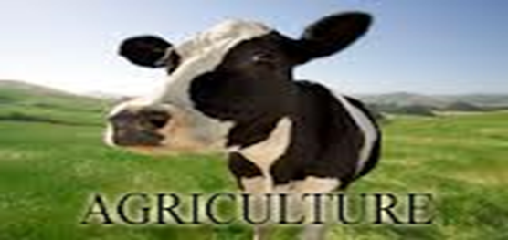

**Topics:**

•       **Healthy Feed Rations: 9:00 a.m. - 10:00 a.m. ( Ed Varnam)**

•  **Feed Storage: 10:00 a.m. - 11:00 a.m. (Ed Varnam)**

•  **Calf Housing and Management: 11:00 a.m. - 12:00 p.m. (Gary Moore)**

**BREAK FOR LUNCH: 12:00 p.m. - 12:30 p.m.**

•  **Hoof Care and Management: 12:30 p.m. - 1:30 p.m. (Charles Biche)**

•  **Calving: 1:30 p.m. – 2:30 p.m. (Jill Greisman)**

•     **Showmanship/Judging: 2:30 p.m.– 4:00 p.m.**

**\*\* Sign-up by July 9th by calling CCEFM. Contact Jake Pamkowski by either email jakepamkowski@yahoo.com or call 518-673-5525.**